INTERDIGITATED ELECTRODES IN MICROFLUIDICS

Erin Ingram & Omar Mahmood

**Concept of Operations**

Concept of Operations

for

Interdigitated Electrodes in Microfluidics

Team #78, Erin Ingram and Omar Mahmood

Approved by:

_____________________________

Erin Ingram Date

_____________________________

Prof. Kalafatis Date

_____________________________

Dalton Cyr Date

**Change Record**

| **Rev.** | **Date** | **Originator** | **Approvals** | **Description** |
| --- | --- | --- | --- | --- |
| **1** | 9/14/2022 | [Erin Ingram, Omar Mahmood] |  | Draft Release |
| **2** | 10/1/2022 | [Erin Ingram, Omar Mahmood] |  | Grammatical and formatting fixes |
| **3** | 12/4/2022 | [Erin Ingram, Omar Mahmood] |  | 403 Final Report |
| **4** | 4/29/2023 | [Erin Ingram, Omar Mahmood] |  | 404 Final Report |

**Table of Contents**

**Table of Contents** 6

**List of Tables** 7

**List of Figures** 8

1. Figure 1: Cross sectional view of the IDE region showing buoyancy of droplets and DEP force acting on different sized microfluidic droplets 11
2. Figure 2: Top view of droplet sorting via single-stage high pass filter. 11
3. Figure 3: Top view of droplet sorting via double-stage band pass filter. 12
4. Figure 4: Birds-eye view of design. 14
5. Figure 5: IDE finger width and spacing. 14
6. Figure 6: 3D CAD model of design with inlet/outlet labels 16

[**1.** **Executive Summary**](https://docs.google.com/document/d/1OfrEkS5eivQflodB7ZnlJtaBA1NvXVnu/edit#heading=h.1t3h5sf) 9

**2.** **Introduction** 10

2.1. Background 10

2.2. Overview 10

2.3. Referenced Documents and Standards 11

**3.** **Operating Concept** 13

3.1. Scope 13

3.2. Operational Description and Constraints 13

3.3. System Description 13

3.4. Modes of Operations 14

3.5. Users 14

3.6. Support 14

**4.** **Scenario(s)** 15

4.1. Cell Biology 15

4.2. Drug Screening 15

4.3. Nucleic Acid Analysis applications 15

**5.** **Analysis** 16

5.1. Summary of Proposed Improvements 16

5.2. Disadvantages and Limitations 16

5.3. Alternatives 16

5.4. Impact 16

**List of Tables**

No table of figures entries found.

**List of Figures**

Figure 1: Cross sectional view of the IDE region showing buoyancy of droplets and DEP force acting on different sized microfluidic droplets 11

Figure 2: Top view of droplet sorting via single-stage high pass filter. 11

Figure 3: Top view of droplet sorting via double-stage band pass filter. 12

Figure 4: Birds-eye view of design. 14

Figure 5: IDE finger width and spacing. 14

Figure 6: 3D CAD model of design with inlet/outlet labels 16

# 

# **1. Executive Summary**

Droplet microfluidics deals with the manipulation of discrete volumes of fluid as small as several microliters through small microchannel devices, and it has shown promise in many different biological and chemical applications, including cell biology, drug screening, and nucleic acid analysis applications. However, as successful as droplet microfluidics is and has the potential to be, there is a problem when it comes to the droplets themselves. Droplets have the ability to merge together or split apart from each other, which often leads to a distortion of the intended droplet size and possible false experimental results in biological and chemical applications. To address these issues, a new method and system must be proposed. Size-based filtration uses electric forces and spatial channels to help direct specific sized droplets to certain outlets to be processed and analyzed. The size-based filtration method can be further enhanced using interdigitated electrode (IDE) arrays. IDE arrays can more finely tune and control electric fields which allows the method to be more sensitive when attempting to spatially filter droplets by dielectrophoretic force. This is a relatively novel solution; however, certain IDE characteristics have not been manipulated to test their effect on filtration accuracy. Optimization of parameters such as IDE finger width, finger spacing, and voltage applied has the potential to usher in a breakthrough in the quality control of droplets in microfluidic systems.

# **Introduction**

## ***2.1. Background***

Droplet microfluidics deals with the manipulation of discrete volumes of fluid as small as several microliters through small microchannel devices [1] and it has shown promise in many different biological and chemical applications, including cell biology, drug screening, and nucleic acid analysis applications [2]. However, as successful as droplet microfluidics is and has the potential to be, there is a problem when it comes to the droplets themselves. Droplets have the ability to merge together or split apart from each other, which often leads to a distortion of the intended droplet size and possible false experimental results in biological and chemical applications. Such an example is in the case of library generation for bacterial and viral experiments where droplets can merge or split with each other containing sensitive organic compounds where mixing is not tolerated. The result is a set of false-positive or false-negative results which might require retesting and can be expensive as well as time consuming. Further, in single-cell analysis, merged droplets can lead to the encapsulation of multiple cells in a single droplet, making it difficult to identify and analyze individual cells.

## ***2.2. Overview***

To address these issues, a new method and system must be developed to address the issue of undesired droplet sizes. Size-based filtration uses electric forces and spatial channels to help direct specific droplet sizes to certain outlets to be processed and analyzed. The size-based filtration method can be enhanced with the use of interdigitated electrode (IDE) arrays [3]. IDE arrays leverage highly localized dielectrophoretic (DEP) force to attract large droplets and filter them out of the main droplet stream, allowing smaller droplets to pass through unaffected and flow to waste.

This method leverages the natural buoyancy of droplets caused by the density difference between the aqueous solution and carrier oil, combined with the DEP force generated by an IDE array at the bottom surface of the microfluidic channel. Due to their natural buoyancy, droplets flow near the top surface of the channel. Because of the electric field at the bottom surface, droplets that are closer to the bottom experience a larger DEP force and are inclined to change direction to follow the IDE into an outlet channel. If a droplet diameter is close to the height of the channel, the droplet is in proximity of the IDE surface and receives a strong DEP force, as depicted in Figure 1. We apply this theory to achieve two different kinds of filtration: high pass and band pass filtration (Figures 2 and 3).

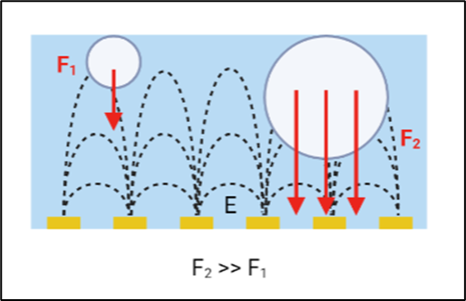

Figure 1: Cross sectional view of the IDE region showing buoyancy of droplets and DEP force acting on different sized microfluidic droplets

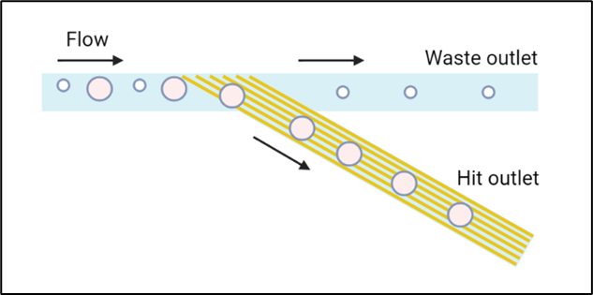

Figure 2: Top view of droplet sorting via single-stage high pass filter.

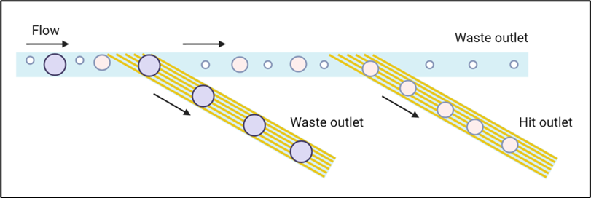

Figure 3: Top view of droplet sorting via double-stage band pass filter.

## ***2.3. Referenced Documents and Standards***

[1] S. Teh *et al*, "Droplet microfluidics," *Lab Chip,* vol. 8, *(2),* pp. 198-220, 2008. Available: [http://dx.doi.org/10.1039/B715524G.](http://dx.doi.org.srv-proxy2.library.tamu.edu/10.1039/B715524G.) DOI: 10.1039/B715524G.

[2] T. S. Kaminski, O. Scheler and P. Garstecki, "Droplet microfluidics for microbiology: techniques, applications and challenges," *Lab Chip,* vol. 16, *(12),* pp. 2168-2187, 2016. Available: [http://dx.doi.org/10.1039/C6LC00367B.](http://dx.doi.org.srv-proxy2.library.tamu.edu/10.1039/C6LC00367B.) DOI: 10.1039/C6LC00367B.

[3] A. Han *et al*, "FIDELITY: A quality control system for droplet microfluidics," *Sci. Adv.,* vol. 8, *(27),* pp. eabc9108, 2022. Available: [https://doi.org/10.1126/sciadv.abc9108.](https://doi-org.srv-proxy2.library.tamu.edu/10.1126/sciadv.abc9108.) DOI: 10.1126/sciadv.abc9108.

[4] *AggieFab Nanofabrication Facility Equipment*. Available: [https://aggiefab.tamu.edu/equipment/.](https://aggiefab-tamu-edu.srv-proxy2.library.tamu.edu/equipment/)

[5] O. Carrier *et al*, "Formation of satellite droplets in flow-focusing junctions: volume and neck rupture," *Microsystem Technologies,* vol. 21, *(3),* pp. 499-507, 2015. Available: [https://doi.org/10.1007/s00542-013-1905-x.](https://doi-org.srv-proxy2.library.tamu.edu/10.1007/s00542-013-1905-x.) DOI: 10.1007/s00542-013-1905-x.

# **Operating Concept**

## ***3.1. Scope***

The two students will individually create two different microfluidics channel designs (Figure 4). We will each start by fabricating our own microchannels and testing from two uniform droplet sizes, small and large, to form a control group. Next we will individually apply different sized based filtrations, IDE arrays, and test for filtration accuracy, and compare to the control group. This testing will be done on the high pass filter, with proof of concept testing done with the bandpass filter. This research explores three different IDE designs – with 5, 10, and 20 micron finger width and spacing (Figure 5). Fabrication will include the use of the Cleanroom in the AggieFab facility for methodologies such as photolithography, softlithography, metal deposition, wet etching, dry etching, and device integration.

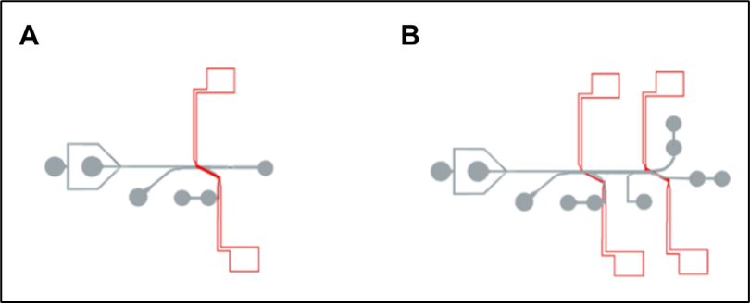

Figure 4: Birds-eye view of design.

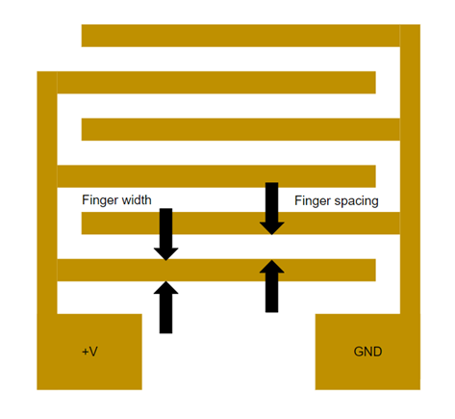

Figure 5: IDE finger width and spacing.

## ***3.2. Operational Description and Constraints***

The system will be designed as a sort of multi-stage filtration system on the micro level. The desired fluid, normally water droplets suspended in an oil solution, will enter the system through an inlet. These droplets will be in different sizes. The droplets will then enter the first IDE junction. The field being produced from the IDE will separate the droplets into two different channels, one channel being “hit” and the other “waste”. In the high pass device, the droplets that are sorted out by IDE will be considered hit, while the droplets that continue to flow straight are considered waste. This device targets satellites, or split droplets. In the bandpass filter, there is a second filtration stage. The droplets that are able to pass through the field of this IDE are waste, while the droplets that are sorted will be considered hits. At the end of this filtration system, the output is a droplet of the correct size and no undesired droplet that comes with it. This will prevent contamination, false readings and unwanted reactions that would have been caused by the split or overmerged droplets. The constraints for this system are as follows:

* Fixed width of the IDE. As of now, the IDE will have a fixed width of 5, 10, or 20 microns and will not be adjustable by the user in the experiment. To adjust the IDE design, a whole new device must be fabricated.
* The field that will be produced by the IDE will not be adjustable during the experiment.

## ***3.3. System Description***

The first subsystem will be a high pass filter. An IDE of a width of between 5 -20 microns will be fabricated. This IDE will then connect to a function generator, and will produce a field to separate the droplets based on size. If a droplet is small enough to pass through the IDE, it will be sent to waste, whereas droplets that are larger enough to interact with the electric field will be sorted out into the hit channel. This system should have a near 100% accuracy rate of filtering out droplets based on size greater than 90 microns.

The second subsystem would be a band pass filter and carry off from the first stage IDE. The first stage should eliminate the largest droplets in the system, or overmerged droplets, leaving medium and small (split) droplets. The second IDE stage sorts the medium, desired droplets away from the unwanted split droplets. The second stage IDE is identical in dimension to the first stage IDE. The droplets collected in the bandpass hit channel are the right size as well as volume and will be used in relevant applications. See Figure 6 for all channel inlet and outlet descriptions.

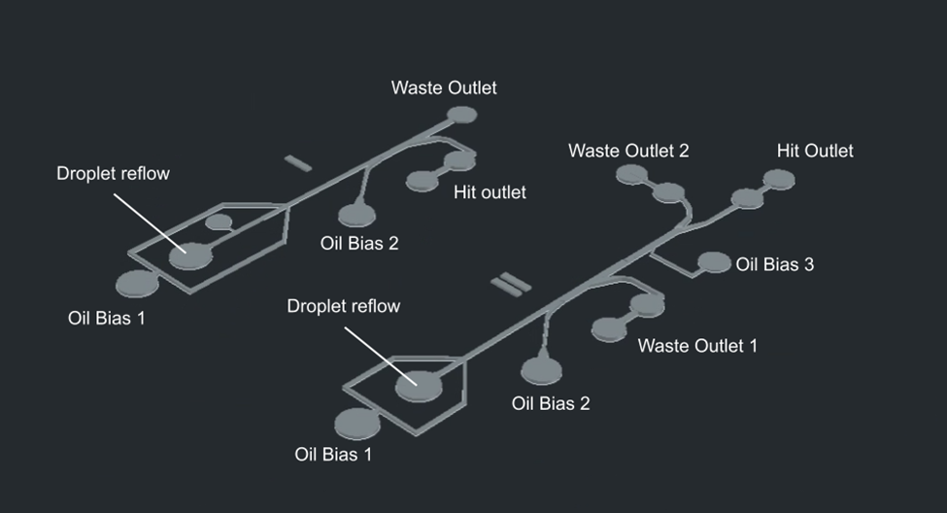

Figure 6: 3D CAD model of design with inlet/outlet labels

## ***3.4. Modes of Operations***

This model will have 2 modes of operation, the high pass and band pass operations, as described in the previous sections.

## ***3.5. Users***

Users of this system will range from drug administrators, point-of-care personnel, cell analysts and researchers. Due to the delicacy of the devices, a training manual will be provided instructing the users how to use the device. Once the manual is read, the device will be plug-and-play. Since the device eliminates unwanted droplets, researchers will benefit as the chance of their sample getting contaminated decreases, cell analysts will benefit due to the requirement of a low volume of analyte, and healthcare personnel will benefit due to the lack of contamination, small volume required, and the added ability to process multiple samples in a much more efficient time.

## ***3.6. Support***

The users will be given a manual that details how to use the device and any safety hazards that are associated with it. The system is plug-and-play, so once the manual is read, there should be no further questions. In the event that there are, there will be a hotline number on the manual.

# **Scenarios**

## ***4.1. Cell Biology***

This scenario is in the case of library generation for viral phages that are effective against antibiotic resistant bacterial infections, where satellite droplets can merge with desired droplets containing sensitive organic compounds where mixing is not tolerated. The result is a set of false-positive or false-negative results which might require retesting and can be expensive as well as time consuming.

## ***4.2. Drug screening***

Droplet microfluidics has great potential in drug discovery since it consumes just a few microliters of sample and only requires small cell numbers for performing large-scale studies. Encapsulation of single cells is essential in such experiments. Co-encapsulation of different cell types due to merging of droplets can be problematic.

## ***4.3. Nucleic acid analysis***

The application of single-cell genome sequencing has been hindered by challenges in isolating single cells during genome preparation. Microfluidics techniques including trapping the cells of interest in hydrogel microspheres are used and optimization of ultrahigh-throughput microfluidics with size-based filtration can further contribute to compartmentalization of each genome.

# **Analysis**

## ***5.1. Summary of Proposed Improvements***

The main improvement that this design has is the multiple IDE filters. This design features a high pass as well as a band pass filter. The combination of these filters will lead to a near 100% accuracy rate sorting out the droplets wanted from the unwanted satellite droplets. The different widths of the IDEs will do this, with the high pass IDE sorting out the big from the small droplets and the band pass filter sorting out the droplets in a more precise manner. This will in turn lead to more efficient screening in applications.

## ***5.2. Disadvantages and Limitations***

A limitation of this system is that it is fixed size and isn’t adjustable. Users could fabricate their own device to fit specific needs based on this design, however the difficulty of fabrication makes this rather inaccessible.

## ***5.3. Alternatives***

Another alternative to reduce the number of satellite droplets would be a sort of centrifugal test, where the fluid would be spun at fast speeds which would in turn cause the fluid to stick together. This setup is more expensive to install and build, and would require much larger volumes of liquid to work than our IDE solution. Overall, our solution of multiple IDE’s working together is cheaper, takes up less space, has an easier training protocol, and requires much less fluid samples to work, in turn saving money. The centrifugal method has longevity on its side, since it has been on the market for a long period of time and has been tested more thoroughly than the IDE technology.

## ***5.4. Impact***

This project has the potential to create a significant positive impact in public health. Bacteria becoming resistant to antibiotics and the rise of superbugs is a grave threat to public health. This new IDE microfluidics technology can contribute to developing treatment of resistant infections with viral phages.

Rectifying this issue in microfluidics will make droplet experiments more accurate and reliable, increasing the integrity of experiments in the fields of microbiology, medicine, etc. Since microfluidics experiments require no more than microliters of samples, increased popularity of these experiments will reduce chemical, biological, and hazardous waste from laboratories, benefiting the environment and safety of those who must work around the hazards.

INTERDIGITATED ELECTRODES IN MICROFLUIDICS

Erin Ingram & Omar Mahmood

**Functional System Requirements**

REVISION – 404 Final Report

29 April, 2023

Functional System Requirements

for

Interdigitated Electrodes in Microfluidics

Prepared by:

Erin Ingram and Omar Mahmood, 4/29/2023

Authors Date

Approved by:

_____________________________

Erin Ingram Date

_____________________________

John Lusher, P.E. Date

_____________________________

Dalton Cyr Date

**Change Record**

| **Rev.** | **Date** | **Originator** | **Approvals** | **Description** |
| --- | --- | --- | --- | --- |
| **1** | 10/3/2022 | [Erin Ingram, Omar Mahmood] |  | Draft Release |
| **2** | 12/4/2022 | [Erin Ingram, Omar Mahmood] |  | 403 Final Report |
| **3** | 4/29/2023 | [Erin Ingram, Omar Mahmood] |  | 404 Final Report |

**Table of Contents**

**Table of Contents** 20

**List of Tables** 21

**List of Figures** 22

**1.** **Introduction** 23

1.1. Purpose and Scope 23

1.2. Responsibility and Change Authority 24

[**2.** **Applicable and Reference Documents**](https://docs.google.com/document/d/1yA6R7yoFtny3VLhE3AauCXFMzsO_JnWL/edit#heading=h.4d34og8) 25

2.1. Applicable Documents 25

2.2. Reference Documents 25

2.3. Order of Precedence 25

**3.** **Requirements** 26

3.1. System Definition 26

3.2. Characteristics 27

3.2.1. Functional / Performance Requirements 27

3.2.2. Physical Characteristics 27

[3.2.3. Electrical Characteristics](https://docs.google.com/document/d/1yA6R7yoFtny3VLhE3AauCXFMzsO_JnWL/edit#heading=h.3j2qqm3) 27

3.2.4. Environmental Requirements 28

3.2.5. Failure Propagation 28

3.2.6 Laboratory Environment 28

3.2.7 Thermal 28

3.2.8 External Contamination 28

3.2.9 Failure Propagation and Safety Considerations 29

**4.** **Support Requirements** 30

**Appendix A Acronyms and Abbreviations** 31

**Appendix B Definition of Terms** 32

**List of Tables**

No table of figures entries found.

**List of Figures**

**Figure 1. Conceptual Image** 23

**Figure 2. Block Diagram of System** 26

# 

# 

# 

# 

# 

# 

# 

# 

# **1. Introduction**

## ***1.1. Purpose and Scope***

In the field of microfluidics, the “mother” droplet is the desired droplet, and this is usually attainable. However, the majority of the time, the mother droplet will be followed by an unwanted, much smaller “satellite” droplet. This satellite droplet can cause cross-contamination, altered test results, and distorted size. To address these issues, a size based filtration system has been put in place, which uses spatial channels to help direct specific sized droplets to certain outlets to prevent mixing of mother and satellite droplets. This method can be further enhanced with the integration of interdigitated electrode (IDE) arrays. These are arrays powered by an AC power source, and have the ability to control and tune electric fields for a more accurate size based separation. The droplets will flow through the channel, and then meet the IDE, which will separate the droplets based on their respective sizes. The satellites will be considered waste, while the regular sized “mother” droplets will be the output.

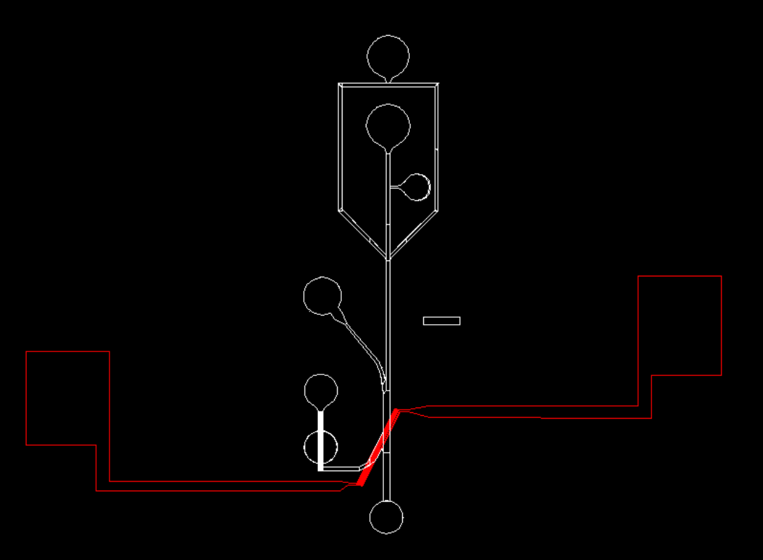

**Figure 1. Conceptual Image**

The following definitions differentiate between requirements and other statements.

Shall: This is the only verb used for the binding requirements.

Should/May: These verbs are used for stating non-mandatory goals.

Will: This verb is used for stating facts or declaration of purpose.

## ***1.2. Responsibility and Change Authority***

The team leader, Erin Ingram, will be responsible for verifying all requirements for the project are met. These requirements can only be changed with the approval of the team leader and the faculty sponsor, Dr. Arum Han.

| Subsystem | Responsibility |
| --- | --- |
| High Pass Filter, Experiments | Omar Mahmood |
| Band Pass Filter, Fabrication | Erin Ingram |

**2.** **Applicable and Reference Documents**

## ***2.1. Applicable Documents***

The following documents, of the exact issue and revision shown, form a part of this specification to the extent specified herein:

| **Document Number** | **Revision/Release Date** | **Document Title** |
| --- | --- | --- |
| DOI: 10.1126/sciadv.abc9108 | 8/8/2022 | FIDELITY: A quality control system for droplet microfluidics |

## ***2.2. Reference Documents***

The following documents are reference documents utilized in the development of this specification. These documents do not form a part of this specification and are not controlled by their reference herein.

| **Document Number** | **Revision/Release Date** | **Document Title** |
| --- | --- | --- |
| DOI: 10.1039/d0lc00757a | 8/28/2022 | An ultra high-efficiency droplet microfluidics platform using automatically synchronized droplet pairing and merging |
| DOI: 10.1039/b715524g | 8/8/2007 | Droplet Microfluidics |
| DOI: 10.1039/c6lc00367b | 5/6/2016 | Droplet microfluidics for microbiology: techniques, applications and challenges |

## ***2.3. Order of Precedence***

In the event of a conflict between the text of this specification and an applicable document cited herein, the text of this specification takes precedence without any exceptions.

All specifications, standards, exhibits, drawings or other documents that are invoked as “applicable” in this specification are incorporated as cited. All documents that are referred to within an applicable report are considered to be for guidance and information only, except ICDs that have their relevant documents considered to be incorporated as cited.

# **3. Requirements**

The droplet filtration device must be able to filter the droplets at least at 90% accuracy. The droplets will first enter the high pass filter, and they will meet an IDE which will separate the satellite droplets from the desired mother droplets. The mother droplets will then enter a PCR machine as an intermediary step. They will then enter the band pass filter, which will separate the post-PCR droplets into three categories based on size. The validation of this experiment will be able to be seen through a high-powered light microscope separate from our device, equipped with a high speed camera. As a result, this filtration device has two subsystems: a high pass filter and a band pass filter.

## ***3.1. System Definition***

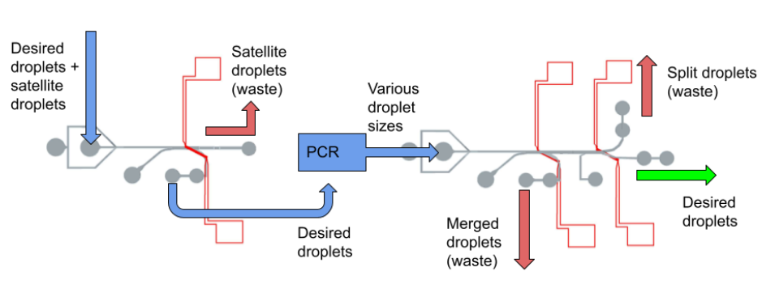

Figure 2. Block Diagram of System

The two separate subsystems are shown above. The left half represents the high pass filter and the right half represents the band pass filter. All droplets, mother and satellites, will enter and travel through the high pass channel where they will ultimately meet an IDE array. The IDE array will apply an electric field which will separate the droplets into a satellite pocket, which will be considered waste, and a mother pocket, which will be considered as the output. Since Polymerase Chain Reaction (PCR) is a common intermediary step in microfluidic applications, we are considering this in our design. The output will then be fed into a PCR machine using special microfluidic tubing. The PCR machine, as an intermediary step, will distort the sizes of the mother droplets, which will be fed into the band pass filter using the same microfluidic tubing. The droplets will then travel through the band pass filter and will be met with a different IDE, which will separate the post-PCR droplets based on size. Droplets that are too big or too small will be considered waste, and the regular sized droplets will be considered as the output of the system.

## ***3.2. Characteristics***

### **3.2.1. Functional / Performance Requirements**

#### **3.2.1.1 90% Accuracy**

The filtration device will have a 90% success rate of filtering out the satellite droplets and ensuring that the regular sized droplets are the output of the system.

*Rationale: The lab has indicated that a 90% success rate will be adequate.*

### **3.2.2. Physical Characteristics**

#### **3.2.2.1. Portability**

The filtration device should be portable and easy to move from one location to the other

*Rationale: This device is fabricated on the micro/nano scale. It is small and easily portable, although caution should be exercised when transporting the device as it is fragile and expensive.*

#### **3.2.2.2. Mounting/Connections**

This device doesn’t require any special mounting. It can be placed on a tabletop or under a microscope for use during experiments. Since portability is a requirement, the devices should also be easily connected to the particular fluid that is being used to generate droplets. Input and output tubing will be attached to the inputs and outputs of the device. The tubing will be detachable on one end which will serve as the input.

*Rationale: As portability is important, the device will not be limited to a certain location. It can be used wherever needed.*

#### **3.2.3 Electrical Characteristics**

#### **3.2.3.1. Inputs**

1. The IDE will be powered by an AC function generator. Experimental results, which are reviewed later in this report, include function generator specifications. Other equipment typically used in conjunction with our device during experiments, such as microscopes and syringe pumps, will require standard wall outlets at 120V (in North America). The fluids used for droplet generation will be pumped into the device using an electronic syringe pump from a third party.

*Rationale: The IDE is made on a micro/nano scale, and needs a small amount of power. The electrical syringe pump is not a part of our device but is needed to insert the fluids into the device at a steady pace.*

##### **3.2.3.2. Power Consumption**

1. The power consumption is nearly negligible.

*Rationale: Since the scale of the IDE array is micrometers, power draw is of miniscule consideration for this device. The IDE array is made of pure gold, which has very little resistance and is one of the best materials to conduct electricity. Silver and copper, the other best conductors, are not used in this device due to their tendency to oxidize.*

##### **3.2.3.3. External Commands**

The voltage applied to this device is user-controlled through an external AC function generator.

#### **3.2.4. Outputs**

##### **3.2.4.1 High Pass Filter**

The high pass filter will use the IDE to deliver the normal sized “mother” droplets to the intermediate PCR machine.

*Rationale: The high pass filter separates the regular size droplets from the small satellite droplets*

##### **3.2.4.2. Band Pass Filter**

The band pass filter will use the IDE to deliver regular sized droplets separate from the droplets that are too large or too small as a result of the PCR intermediate step.

*Rationale: Droplet size is largely distorted during the PCR process, and some droplet sizes may not be viable for the particular experiment.*

### **3.2.5. Environmental Requirements**

The filtration device shall be designed to withstand and operate in the environments and laboratory tests specified in the following section.*.*

#### **3.2.6. Laboratory Environment**

The device will operate primarily in a laboratory and/or clinical setting where other necessary equipment such as a syringe pump and microscope are readily available and natural elements such as dirt are at a minimum. We do not recommend using this device outdoors or in non-laboratory environments where dust and other microscopic contaminants could tamper with the user’s experimental results.

*Rationale: The device needs additional equipment to work as intended, found in a lab setting. Natural elements may interfere with the function of the device if they contaminate it.*

#### **3.2.7. Thermal**

The device will not be able to function properly if the surrounding temperatures are below the freezing point or above the boiling point of the liquids used in experimentation. These boundaries are user-defined. Water is common to these experiments and presents the tightest temperature restriction, which is still very suitable for laboratory conditions. We do not recommend storing the device in laboratory cryogenic chambers that exceed -40℃, or ovens that exceed 150℃, as this will damage the device.

#### **3.2.8. External Contamination**

Since the device is on a micro level, contaminants such as dust and dirt will affect the function of the device in a negative way. It needs to be kept free of external contamination. The device can be easily shielded from contamination during idle time by keeping it enclosed in a petri dish and away from busy areas in the lab.

### **3.2.9. Failure Propagation and Safety Considerations**

This is a delicate device that is susceptible to breakage through falling and excessive thermal conditions. If this should happen, the device will simply need to be replaced. If the IDE substrate part of the device shatters, users should beware of sharp corners and use proper laboratory PPE to prevent lacerations of the skin during cleanup. Other parts of the device are made of flexible material that will not shatter or create sharp edges. Breakage or damage of the device should not result in serious injury to users.

# **4. Support Requirements**

The user of this device will need an electronic syringe pump for the fluid deposition into the channel. A PCR machine will be required to conduct the intermediary PCR step. A microscope may be wanted to perform a proof-of-concept trial but is not needed for the device to function. The system will come with built in filtration and a power source for the IDE. An instruction manual will be provided with the device.

# **Appendix A: Acronyms and Abbreviations**

DEP Dielectrophoretic

DNA Deoxyribonucleic Acid

IDE Interdigitated Electrode

PCR Polymerase Chain Reaction

PECVD Plasma Enhanced Chemical Vapor Deposition

PDMS Polydimethylsiloxane

µm Micrometer

# **Appendix B: Definition of Terms**

**Dielectrophoretic (DEP) Force:** A phenomenon in which a force is exerted on a dielectric particle when it is subjected to a non-uniform electric field. This force does not require the particle to be charged. Fields of a particular frequency can manipulate particles with great selectivity.

**Interdigitated Electrode (IDE):** two electrode arrays combined in a zipper or comb-like arrangement. Fabricated via metal deposition on a glass substrate.

**Polymerase Chain Reaction (PCR):** A laboratory technique used to rapidly amplify segments of DNA, creating millions to billions of copies within hours, such that the genetic information can be studied in detail.

INTERDIGITATED ELECTRODES IN MICROFLUIDICS

Erin Ingram & Omar Mahmood

**Interface Control Document**

REVISION – 2

29 April, 2023

Interface Control Document

for

Interdigitated Electrodes in Microfluidics

Prepared by:

Erin Ingram and Omar Mahmood, 4/29/2023

Authors Date

Approved by:

______________________________

Erin Ingram Date

_____________________________

John Lusher II, P.E. Date

_____________________________

Dalton Cyr Date

**Change Record**

| **Rev.** | **Date** | **Originator** | **Approvals** | **Description** |
| --- | --- | --- | --- | --- |
| **-** | 9/30/22 | Erin Ingram, Omar Mahmood |  | Draft Release |
| **1** | 12/4/2022 | Erin Ingram, Omar Mahmood |  | Revising grammar and formatting errors |
| **2** | 4/29/2023 | Erin Ingram, Omar Mahmood |  | 404 Final Report |

**Table of Contents**

**Table of Contents** 36

**List of Tables** 37

**List of Figures** 38

[**1.** **Overview**](https://docs.google.com/document/d/1m9-Vp3o05irjHcE71DsaR-VeSARY9iMy/edit?mode=html#heading=h.1t3h5sf) 39

1[.1. References](https://docs.google.com/document/d/1m9-Vp3o05irjHcE71DsaR-VeSARY9iMy/edit?mode=html#heading=h.2s8eyo1) 40

1[.2. Definitions](https://docs.google.com/document/d/1m9-Vp3o05irjHcE71DsaR-VeSARY9iMy/edit?mode=html#heading=h.17dp8vu) 40

**2**[**.** **Physical Interface**](https://docs.google.com/document/d/1m9-Vp3o05irjHcE71DsaR-VeSARY9iMy/edit?mode=html#heading=h.26in1rg) 41

2[.1. Weight](https://docs.google.com/document/d/1m9-Vp3o05irjHcE71DsaR-VeSARY9iMy/edit?mode=html#heading=h.lnxbz9) 41

2.2. Dimensions 41

3.2.1. Dimension of High Pass Unit 41

3.2.2. Dimension of Band Pass Unit 41

2[.3. Mounting Locations](https://docs.google.com/document/d/1m9-Vp3o05irjHcE71DsaR-VeSARY9iMy/edit?mode=html#heading=h.35nkun2) 42

**3**[**.** **Thermal Interface**](https://docs.google.com/document/d/1m9-Vp3o05irjHcE71DsaR-VeSARY9iMy/edit?mode=html#heading=h.z337ya) 44

**4****.** **Electrical Interface** 45

4[.1. Primary Input Power](https://docs.google.com/document/d/1m9-Vp3o05irjHcE71DsaR-VeSARY9iMy/edit?mode=html#heading=h.1y810tw) 45

4[.2. IDE](https://docs.google.com/document/d/1m9-Vp3o05irjHcE71DsaR-VeSARY9iMy/edit?mode=html#heading=h.4i7ojhp) 45

4[.3. Video Interfaces](https://docs.google.com/document/d/1m9-Vp3o05irjHcE71DsaR-VeSARY9iMy/edit?mode=html#heading=h.2xcytpi) 45

4.4 User Control Software45

**5****.** **Communications / Device Integration** 46

**List of Tables**

Table 1: High Pass Subsystem Weight 41

Table 2: Band Pass Subsystem Weight 41

Table 3: High Pass Subsystem Dimensions 41

Table 4: Band Pass Subsystem Dimensions 41

**List of Figures**

# Figure 1. 3D rendering of Channel Design 44

# Figure 2. High Pass Filter physical design 45

Figure 3. Softlithography chip fabrication using PDMS 46

# **1. Overview**

This document is provided to detail how the two stages of the droplet filtration system will interface with each other. It will list the inputs, outputs and how the system will manage each input and output. The microfluidic channel and interdigitated electrode arrays will be detailed for both subsystems as well.

# **References and Definitions**

## ***References***

Refer to section 2.2 of the Functional System Requirements document.

## ***Definitions***

DEP Dielectrophoretic

DNA Deoxyribonucleic Acid

IDE Interdigitated Electrode

PCR Polymerase Chain Reaction

PECVD Plasma Enhanced Chemical Vapor Deposition

PDMS Polydimethylsiloxane

µm Micrometer

# **Physical Interface**

Provide details on the physical interface.

## ***Weight***

**2.1.1 High Pass Unit**

| Component | Weight | Number of Items | Total Weight |
| --- | --- | --- | --- |
| High pass channel | 1 oz | 1 | TBD |
| High pass IDE | 1 oz | 1 | TBD |

Table 1: High Pass Subsystem Weight

**2.1.2 Band Pass Unit**

| Component | Weight | Number of Items | Total Weight |
| --- | --- | --- | --- |
| Band pass channel | 1 oz | 1 | TBD |
| Band pass IDE | 1 oz | 1 | TBD |

Table 2: Band Pass Subsystem Weight

## ***Dimensions***

### **Dimension of High Pass Unit**

| Component | Length | Width | Height |
| --- | --- | --- | --- |
| High pass channel | 14500 µm | 4020 µm | 120 µm chamfered to 100 µm |
| High pass IDE | 1 in | 0.5 in | 1/16 in |

Table 3: High Pass Subsystem Dimensions

### **Dimension of Band Pass Unit**

| Component | Length | Width | Height |
| --- | --- | --- | --- |
| Band pass channel | 19300 µm | 6400 µm | 120 µm |
| Band pass IDE | 1 in | 0.5 in | 1/16 in |

Table 4: Band Pass Subsystem Dimensions

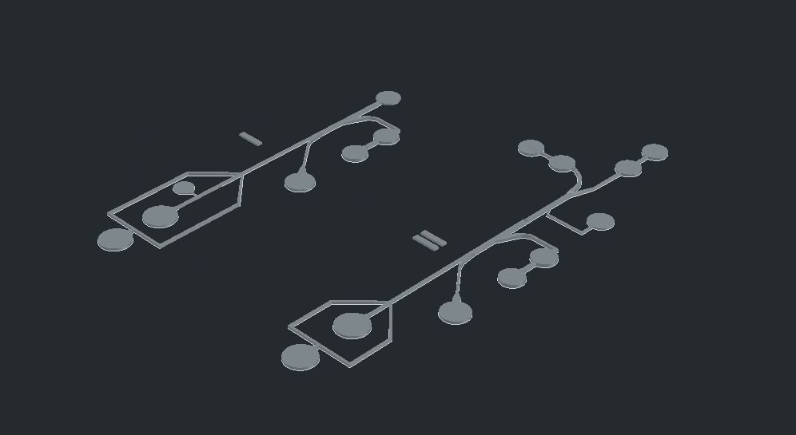

Figure 1. 3D rendering of Channel Design (I: High pass, II: Band pass)

## ***Mounting Locations***

The IDEs for each filter will be placed at the last junctions of both filters (Figure 1). The output of the high pass filter will then be fed into an intermediate PCR* machine using tubing. The output droplets from the PCR equipment will be fed into the band pass filter using tubing. The process of aligning and placing the IDEs onto the microfluidic channels will be done via plasma bonding, which ionizes the atoms on both surfaces to create a very strong bond between the two components when pressed together.

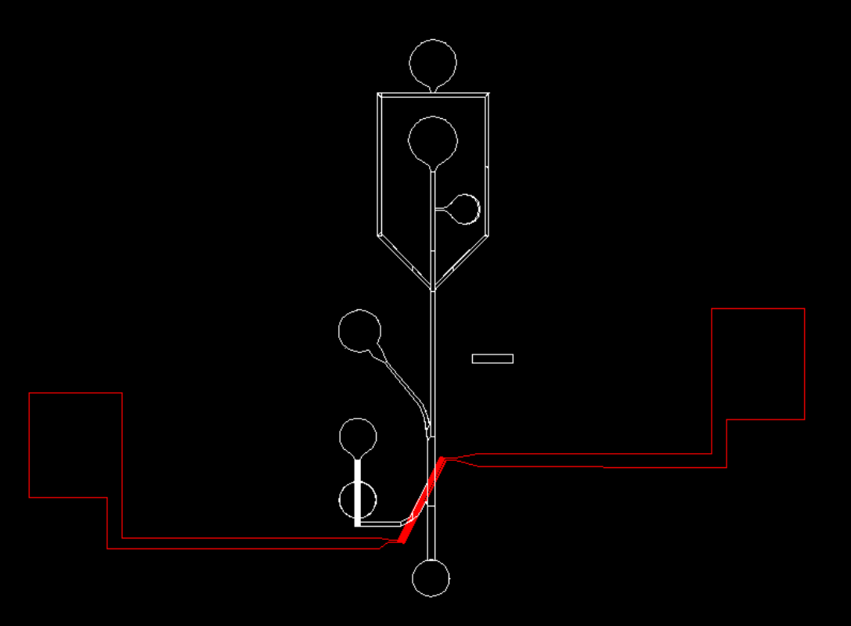

Figure 2. High Pass Filter – channel (white) and aligned IDE (red)

*Polymerase Chain Reaction (PCR) is a process commonly used in biological experiments. It involves rapid replication of DNA for applications such as crime forensics, drug screening and development, and infection diagnostics. This process requires uniform input droplets to trap single DNA molecules inside. To facilitate the process of artificial DNA replication, significant temperature changes take place which disturbs droplets leading to splitting and merging. We are designing our filtration system around the needs and consequences of the PCR process since it is a practical application of the technology.

# **Thermal Interface**

The PDMS used during softlithography for channel fabrication (Figure 3) has a temperature range of -40*℃* to 150*℃*. The IDEs will be fabricated using gold deposition, which has a temperature range of up to to 1000*℃.* Given these broad temperature ranges, it is unlikely that we will need any thermal interfaces for the device.

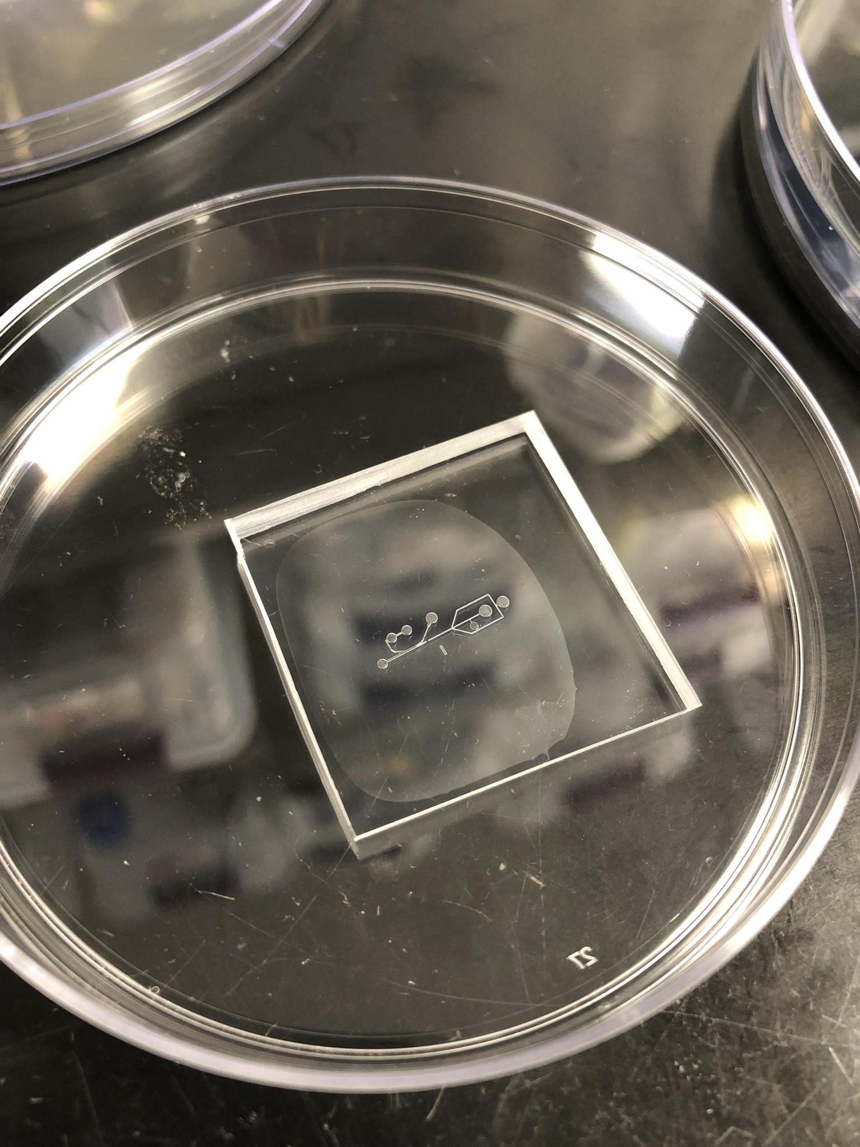

Figure 3. Softlithography chip fabrication using PDMS

# **Electrical Interface**

## ***Primary Input Power***

The input power will be an AC function generator. A connection will be soldered onto the IDE for a battery, and a function generator source will be used to power the IDE. The droplets will be pumped into the channel using a syringe pump, which will be connected to a standard wall outlet.

## ***IDE***

The IDE will be used to separate the droplets based on size. It will be fabricated using gold deposition. The power it receives from the AC source will create an electric field between the fingers. When droplets pass through this electric field, they will be sorted to the corresponding output based on size via highly localized DEP force.

## ***Video Interfaces***

During experimentation, a light microscope equipped with a high speed camera (1000 frames per second) will be used to take video recordings of droplet generation and the filtration processes. This will be used during validation to test the success of the device.

## ***User Control Interface***

The user interface of this device will consist of tubing and syringes for inputs to the first stage (high pass filter), output requiring transportation to PCR equipment, and finally a second set of syringes and tubing for input to the second stage (bandpass filter). The user might want to use additional equipment including microscopes and high-speed cameras to validate results of their own applications.

# **Communications / Device Interface Protocols**

This device is an isolated lab-on-a-chip, used to mitigate the problem of unwanted droplet sizes in microfluidics. As such, it does not communicate electronically with other devices or systems.

INTERDIGITATED ELECTRODES IN MICROFLUIDICS

Erin Ingram & Omar Mahmood

**Milestones and Validation Plan**

## 

## 

## 

## 

## 

## Milestones

**ECEN 403**

| **9/16/22** | Train on non-cleanroom related techniques and equipment:   * Softlithography * Plasma cleaner * Microscopes * Syringe pumps * Droplet generation validation procedures * PCR |
| --- | --- |
| **9/30/22** | Design microfluidic channels, fabricate master molds using NanoScribe in AggieFab. |
| **10/14/22** | Design IDEs, train on cleanroom tasks including:   * Metal deposition * Wet etching |
| **10/28/22** | Finish fabrication of device by plasma bonding the microfluidic channels onto the IDE arrays. |
| **11/11/22** | Perform experiments using the bonded device. Experiment with different IDE designs fabricated. Perform simulations using COMSOL. Validate subsystems through comparison to control group and simulations. |
| **11/25/22** | Test using ideal IDE parameters discovered in previous experimentation. |

**ECEN 404**

| **2/22/23** | * Complete image processing on our previous experiments * At least one experiment |
| --- | --- |
| **3/8/23** | Continue experiments |
| **3/29/23** | Continue experiments |
| **4/5/23** | * Image analysis on all experiments * Thesis final installment |
| **4/19/23** | Finalize optimal device design |
| **5/3/23** | Validation of entire system |

## 

## Validation Plan

Experimental results and the device’s overall success will be validated by reaching 90% efficiency of droplet sorting as compared to real droplet generation with no IDE array present. This benchmark has been provided by the NanoBio Systems Laboratory, which this project is a part of.

| **TESTING / VALIDATION** | Omar (High-pass) | Erin (Band-pass) |
| --- | --- | --- |
| Channel print quality (leaks, blockages) | ✅ | ✅ |
| Droplet generation | ✅ | N/A |
| Fluid biasing | ✅ | ✅ |
| IDE quality | ✅ | ✅ |
| Filtration w/ IDE | ✅ | ✅ |

INTERDIGITATED ELECTRODES IN MICROFLUIDICS

Omar Mahmood

**High-Pass Filter Subsystem Report**

**Table of Contents**

List of Figures …………………………………………………………………………………..52

List of Tables ……………………………………………………………………………………53

1. Introduction ……………………………………………………………………………..54

2. Theory …………………………………………………………………………………..55

3. Design …………………………………………………………………………………..57

4. Operation ……………………………………………………………………………….60

5. Data Collection ……………………………………………………………………...…61

6. Conclusion …………………………………………………………………………..…62

6.1 Learnings ………………………………………………………………….……….62

6.2 Future Works ………………………………………………………………………62

**List of Figures**

Figure 1: Diagram of high-pass filter ……………………………………………………..54

Figure 2: Conceptual Scope of High-Pass Filter ………………………………………….55

Figure 3: COMSOL simulations of electric fields at 10um spacing and width …………..56

Figure 4: Bonded Device with proper alignment under a microscope ……………………57

Figure 5: Top view of bonded device ……………………………………………………..58

Figure 6: Experimental setup from the left ……………………………………………….58

Figure 7: Experimental setup from the right ………………………………………………59

Figure 8: Droplets being sorted using the device ………………………………………….60

**List of Tables**

Table 1: Table of experimental results ……………………………………………………..61

**1. Introduction**

The purpose of this document will be to discuss the High Pass Filter Subsystem of the overall Microfluidic Parser. The High Pass Filter focuses on the separation of larger droplets (100 um+) from the smaller droplets. This subsystem is the vital precursor to the band pass filter, and contributes to the main output of the parser, a series of uniform droplets with no satellites. This report will cover aspects such as theory, design, operation and data collection.

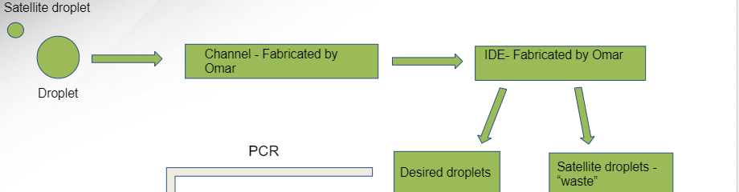

*Figure 1: Diagram of high-pass filter*

**2. Theory**

The scope of this subsystem was to create a method for separating larger droplets from smaller ones. These larger droplets would then be fed into an intermediate PCR process. This involved designing and creating a microfluidic channel and an Interdigitated Electrode Array (IDE). For the purposes of this presentation, the fluid would be a water-based solvent, biased by a diluted surfactant. The IDE chosen had fingers that were 10um wide and spaced out by 10um. This was based off of simulations conducted on COMSOL, which indicated that the electric field produced by these dimensions would be sufficient enough to separate droplets. The droplets would reach the IDE, which would be charged by a voltage of around 200mV, creating an electrical field. This field would direct larger droplets into a specialized outflow channel and would direct the smaller droplets into a waste channel.

The original high pass filter contained an integrated droplet generator. This meant that droplets would be generated from the channel itself. However, this was altered to using a third party specialized droplet generator. This generator provided more uniform droplet sizes. These droplets were then fed into the input of the high pass filter.

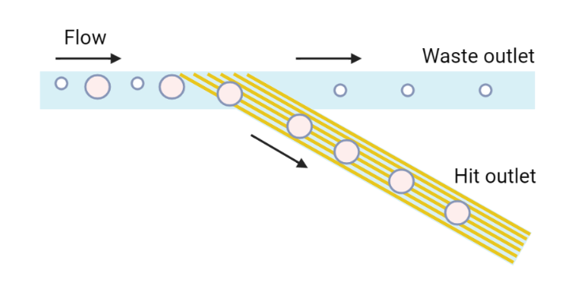

*Figure 2: Conceptual Scope of High-Pass Filter*

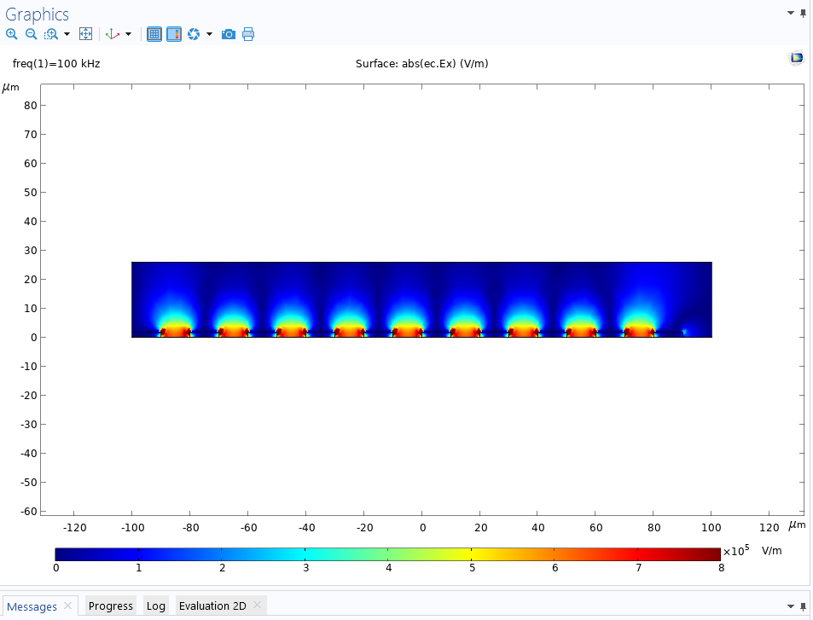

*Figure 3: COMSOL simulations of electric fields at 10um spacing and width*

**3. Design**

To begin, we will mention the hardware that was utilized in the high pass filter. A microfluidic channel was first designed and fabricated for the droplets to move through and for the experiment to take place. The channel was designed to have a height of 120um to facilitate droplet movement. The channel contained some slopage for the outputs, so height varied slightly. These channels were designed in AutoCAD, and then 3D printed onto a silicon wafer using a NanoScribe machine. Once printed, the wafers underwent a soft-lithography treatment utilizing PDMS. PDMS was spread over the wafer, baked at 70 degrees Celsius, and then brought out, cut and holepunched. This soft-lithography was undergone multiple times to produce multiple channels.

To create the IDE, a nanofabrication cleanroom facility was used. A gold-deposited slide of glass was used to begin with. A mask of the IDE was placed over and etched into the slide. The slide then underwent processes such as photolithography, wet-etching and Plasma Enhanced Chemical Vapor Deposition (PECVD) in order for it to be completed. Once completed, the IDE was ready to be bonded to the channel.

To bond both devices together, a plasma bonder was used. Both the IDE and the channel underwent a treatment with oxygen plasma. Once ready, a microscope was used to align the IDE to the part of the channel where the sorting would happen. The terminals of the IDE were then soldered to wires, which would be connected to the power source supplying 200mV-500mV.

To begin the experiment, some third party equipment was used. A droplet generator was used to generate the droplets. Three electronic syringe pumps were used. One was used to pump droplets, two were used for fluid biasing using a diluted surfactant solution. Droplets were pumped and biased, and once they reached the IDE, the voltage induced an electric field, which separated the droplets based on size.

*Figure 4: Bonded Device with proper alignment under a microscope*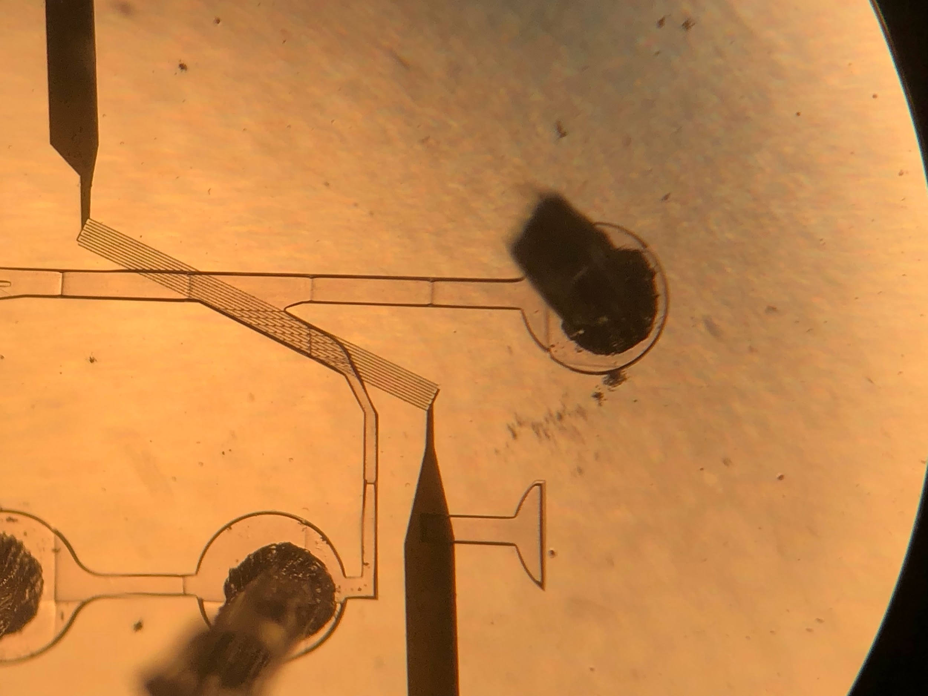

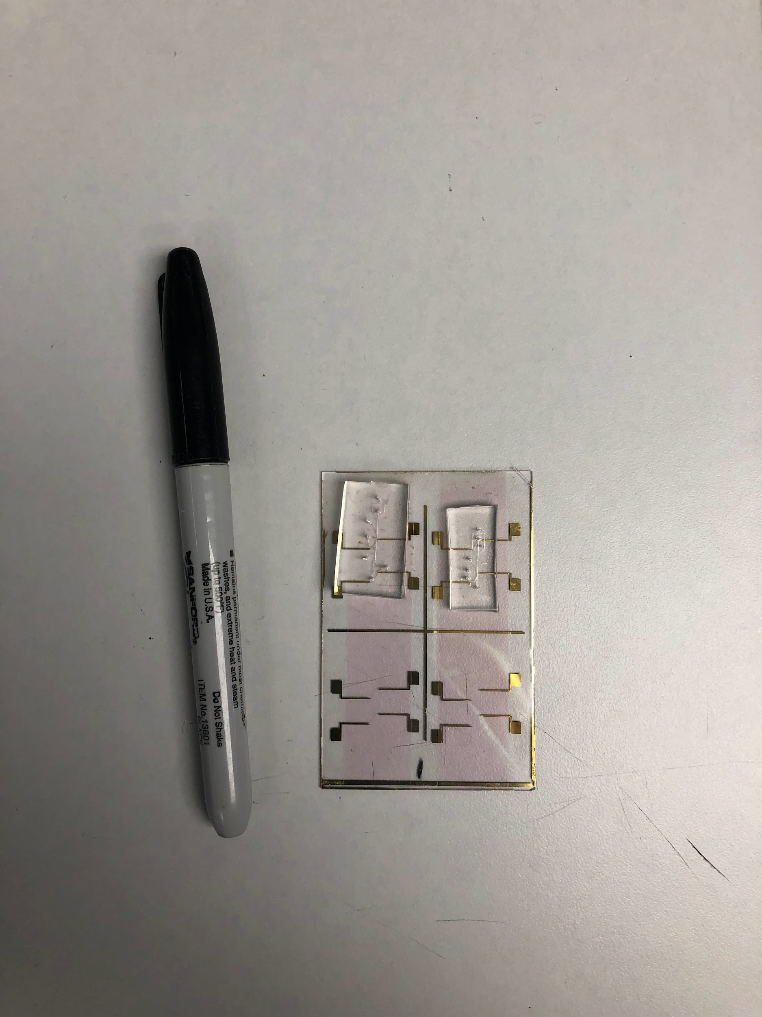

*Figure 5: Top view of bonded device*

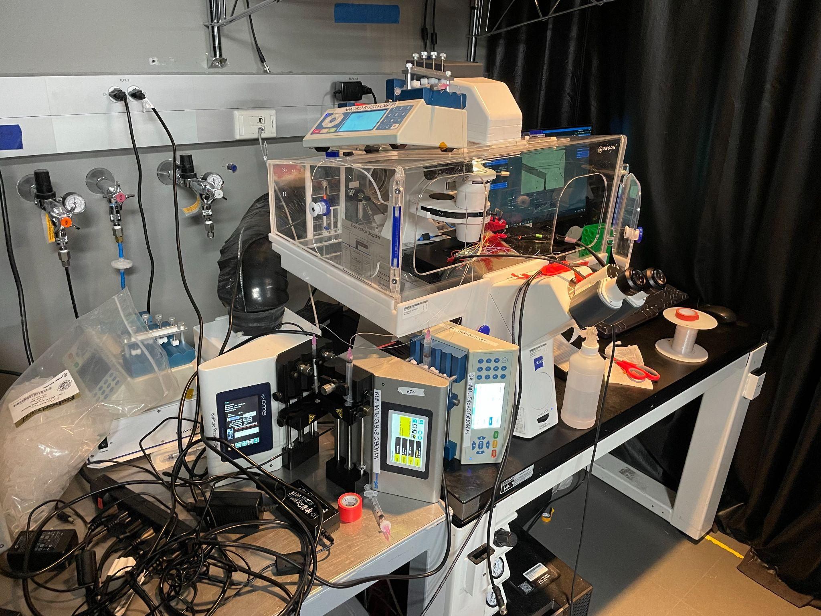

*Figure 6: Experimental setup from the left*

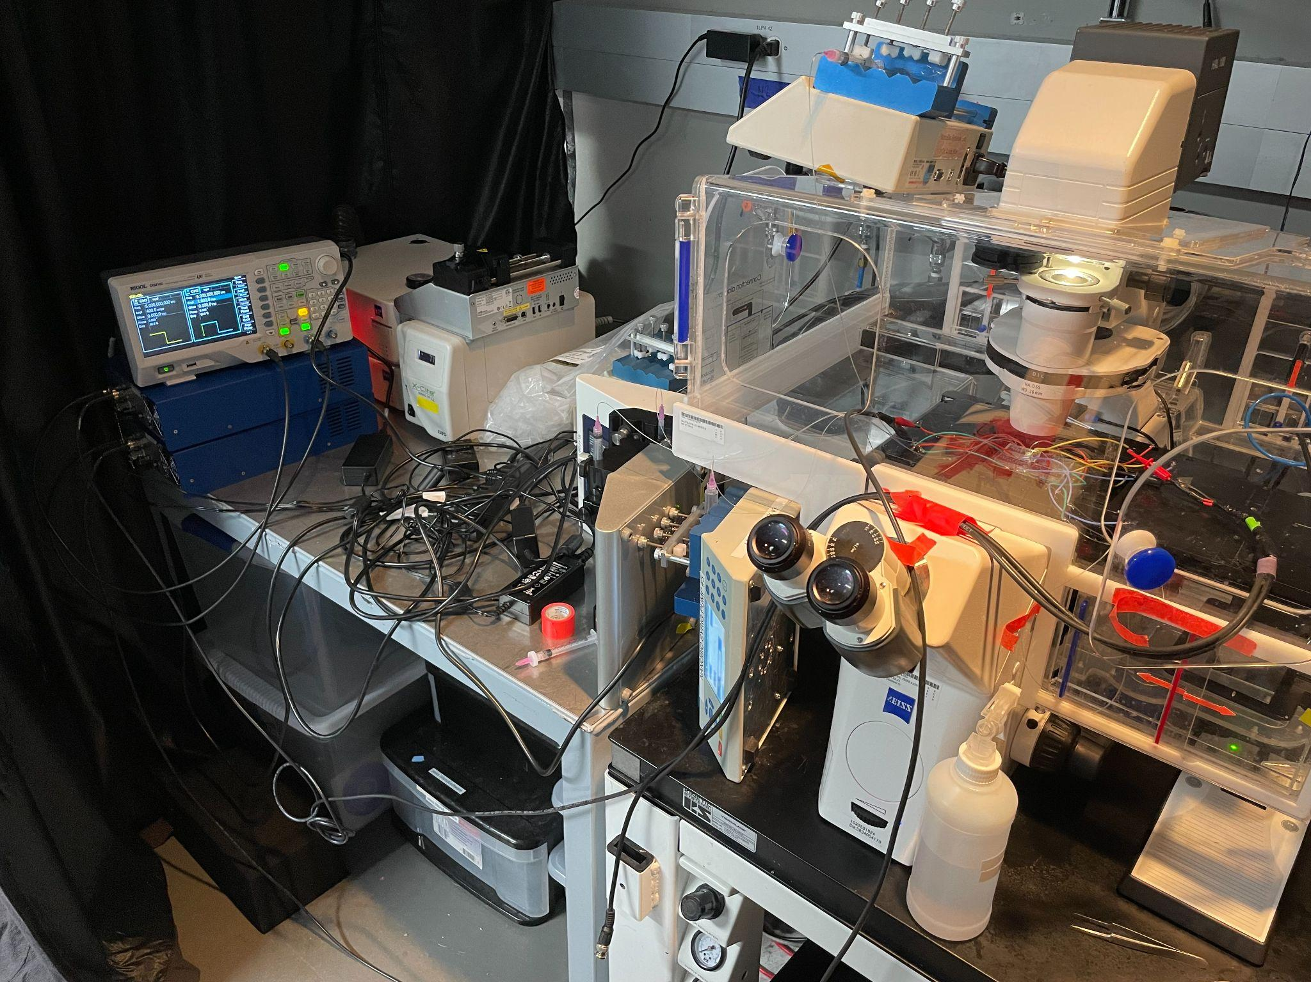

*Figure 7: Experimental setup from the right*

**4. Operation**

There were two primary stages of validation to ensure that the high pass filter was operating properly. The first phase was to ensure that the channel was fabricated correctly. This meant ensuring that there were no cracks or blockages in the channel and that the prescribed dimensions were correctly fabricated. This was done by passing fluids through the channel and viewing the process under a high powered microscope.

The second stage of validation was ensuring that the IDE fabrication was done correctly. There are a lot of factors that can affect the quality of fabrication. This was validated in a similar way to the channel, where the IDE was looked at under a heavy duty microscope and was checked for cracks and debris. A voltage was also passed through it to ensure that it worked.

At this point came full system integration. In full system integration, the channel was bonded to the IDE via a plasma bonder. This integration was the setting for the experiment. The larger droplets were dyed black to visually differentiate them. Droplets were passed through the channel and the IDE was activated and sorted them based on size successfully.

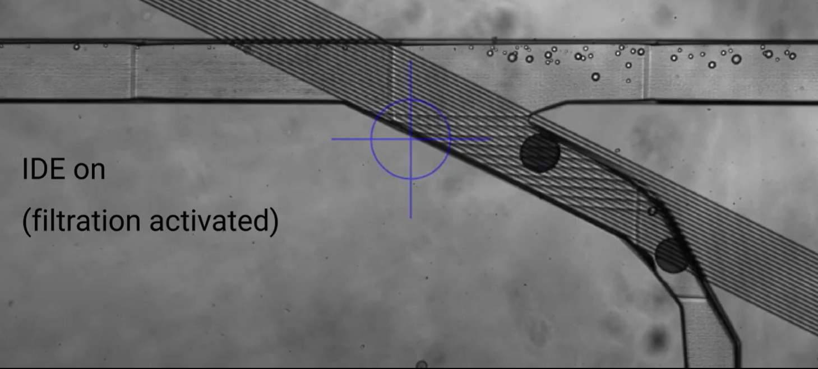

*Figure 8: Droplets being sorted using the device*

**5. Data Collection**

The validation of both individual phases of the filter were more qualitative than quantitative. The validation of the full system can be found in Table 1. A sorting accuracy of 90% was acceptable for the lab and an accuracy of 100% was considered excellent. From this table, it is clear to see that the accuracy achieved meets the requirement set forth by the lab. The average efficiency for all trials is around 96%.

| Trial | Total number of droplets 100um+ created | Droplets 100um+ that were sorted (true pos) | Droplets 100um+ that were not sorted (false neg) | Number of droplets less than 100um that were sorted |
| --- | --- | --- | --- | --- |
| 1 | 100 | 94 | 6 | 0 |
| 2 | 200 | 192 | 8 | 0 |
| 3 | 250 | 240 | 10 | 0 |
| 4 | 500 | 486 | 14 | 0 |
| Total | 1050 | 1012 | 38 | 0 |

*Table 1: Table of experimental results*

**6. Conclusion**

The high pass filter is an integral component of the microfluidic parser because it works closely with the other subsystem and produces the system's primary output and is required for the other subsystem to work correctly.

**6.1 Learnings**

Over the course of working on this subsystem, valuable knowledge was gained in several areas. In addition to learning about the field of microfluidics, one of the most important learning outcomes was the fabrication process and different methodologies associated with it. I had zero practical experience with fabrication, but it quickly became the backbone of the high pass filter. Along with the fabrication came the reinforcement of principles of electromagnetic fields. Software such as COMSOL Multiphysics and AutoCAD also became important assets. Lastly, important lessons were learned in teambuilding and the importance of proper communication.

**6.2 Future Works**

This semester served as a proof of concept for the high pass filter. Next semester, different parameters of the IDE will be tested. These parameters include different widths and spacing between the fingers of the IDE. The difference that these changes bring will be observed. Another goal for next semester is to try to bring the accuracy up to around the 100% mark. This will be good because it would eliminate the waste of good droplets as well as the removal of satellite droplets. Next semester, we will also determine the threshold voltage needed to sort different droplet sizes.

INTERDIGITATED ELECTRODES IN MICROFLUIDICS

Erin Ingram

**Band-Pass Filter Subsystem Report**

**Table of Contents**

List of Figures …………………………………………………………………………………..65

List of Tables ……………………………………………………………………………………66

1. Introduction ……………………………………………………………………………..67

2. Theory …………………………………………………………………………………..68

3. Design …………………………………………………………………………………..70

4. Operation ……………………………………………………………………………….71

5. Data Collection …………………………………………………………………………73

6. Conclusion ………………………………………………………………………………74

6.1 Learnings …………………………………………………………………………….74

6.2 Future Works …………………………………………………………………..……74

**List of Figures**

Figure 1: Band-pass filter subsystem block diagram…………………………………………….67

Figure 2: Conceptual Scope of Band-Pass Filter………………………………………………...68

Figure 3: COMSOL simulations of electric fields with 5um IDE array…………………………69

Figure 4: Bonded device, pre-soldering (band-pass filter device on bottom)................................70

Figure 5: Device being operated under the microscope, equipped with tubing and wires………71

Figure 6: First stage of the band-pass filter, under the microscope……………………………...72

Figure 7: Second stage of the band pass filter, under the microscope…………………………...72

**List of Tables**

Table 1: Table of experimental results ……………………………………………………..73

**1. Introduction**

The purpose of this report is to discuss the band-pass filter subsystem of the microfluidic parser, a microfluidic lab-on-a-chip device that uses interdigitated electrodes (henceforth, “IDE”) to perform size-based filtration of fluid droplets on the scale of microns. The bandpass filter sorts out excessively large and excessively small droplets from the desired medium droplet size, ~80 microns. This report will cover theory of the subsystem, design, operation, and data collection/analysis.

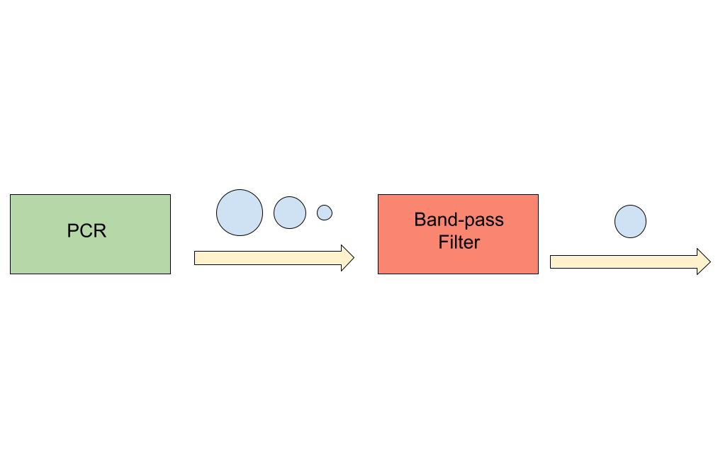

*Figure 1: Band-pass filter subsystem block diagram*

**2. Theory**

The scope of this subsystem is a physical channel for fluid to flow through as well as IDEs to perform filtration. Specifically, droplets >100 microns (waste) in diameter are sorted out in its first stage, and droplets >80 microns (hit) are sorted out in its second stage, allowing droplets <80 microns (waste) to pass through. This subsystem is a vital component of the device when polymerase chain reaction (PCR) is performed as an intermediate step in a microfluidics experiment, which is common. PCR results in varied droplet sizes and it is essential to experimental precision that unwanted droplet sizes are filtered out. In the experiments performed to validate the subsystem, water droplets are suspended in a diluted surfactant.

The IDE chosen for this experiment was a 5um array, meaning finger width is 5um and finger distance is 5um. This was partly chosen from COMSOL simulations and partly chosen from quality assurance during fabrication. The COMSOL simulation indicated that a 5um array would be sufficient to reach the droplets via electric field. Quality assurance during fabrication left limited options of IDEs to choose from.

The IDEs are powered by a function generator outputting a 5kHz 200mV sine wave. The generated electric field directs large and medium size droplets into outflow channels while small satellite droplets pass through unaffected. Large droplets and satellite droplets are sent to waste while the medium droplets are collected.



*Figure 2: Conceptual Scope of Band-Pass Filter*

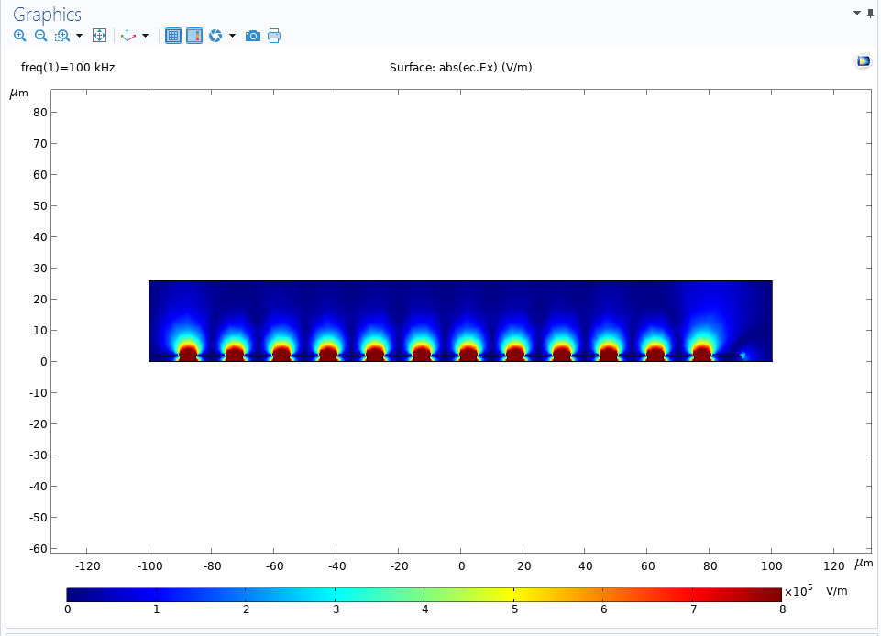

*Figure 3: COMSOL simulations of electric fields with 5um IDE array*

**3. Design**

First, microfluidic channels were designed in AutoCAD. The channel dimensions were designed to accommodate intended droplet sizes. The height of the output channels tapers down to help facilitate movement. Channel design is something that has already been researched and optimized in the field of microfluidics, so this is not the focus of innovation in this project. The channel was 3D printed onto a silicon wafer using NanoScribe, a high precision printer. After printing, soft-lithography is performed to create soft channel chips. The steps of soft-lithography include mixing PDMS with a curing agent, pouring it over the printed master mold, degassing the mixture in a vacuum chamber, and finally placing it in the oven at 70 degrees C to harden. After hardening, the chips are cut out and hole-punched to allow for tubing connections for fluid injection.

After the channels were designed and fabricated, the IDEs were designed and fabricated. AutoCAD was used to design the IDEs and a mask was created for use in fabrication. AggieFab, a nanofabrication cleanroom facility, was used for fabrication. A glass slide thinly coated in gold was treated with positive and negative photoresist and exposed to UV light to imprint the IDE pattern onto the gold slide. After photolithography, wet etching was performed to remove the unwanted gold, leaving only the IDE pattern. Then, silicon nitride deposition is performed with a PECVD machine to protect the delicate gold fingers of the IDE.

Once both the channels and IDEs are fabricated and quality assured, the two are bonded together using a plasma cleaner machine and oxygen plasma. Once plasma treated, the channel is properly aligned with the IDE under a microscope. Wires are then soldered onto the IDE pads to provide connections between the device and function generator.

*Figure 4: Bonded device, pre-soldering (band-pass filter device on bottom)*

**4. Operation**

To operate this device, several steps need to be taken. Tubing needs to be attached to the holes punched into the device to allow for fluid injection into the channels. A syringe pump equipped with water and oil syringes is needed to inject fluid at steady, controlled rates. A microscope is needed to observe the operation of the device.

The first step in operation/experimentation is ensuring that there are no leakages or blockages. This consists of pushing fluid through the channels and confirming that it exits through the proper output.

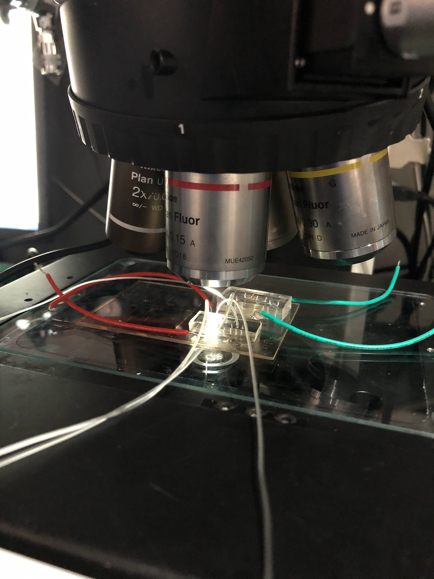

*Figure 5: Device being operated under the microscope, equipped with tubing and wires*

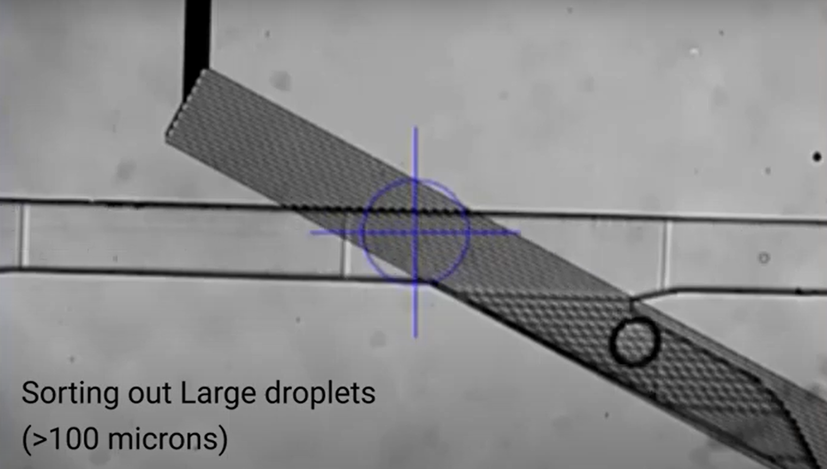

*Figure 6: First stage of the band-pass filter, under the microscope*

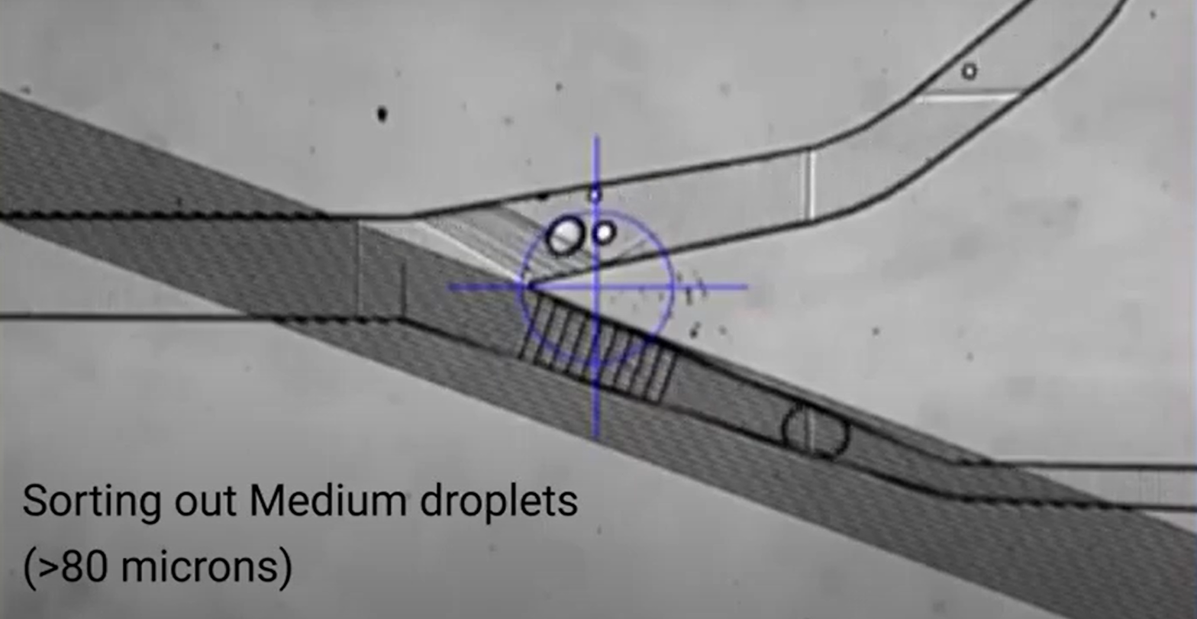

*Figure 7: Second stage of the band pass filter, under the microscope*

**5. Data Collection**

The validation of this subsystem was largely qualitative, ensuring the quality of the device visually under a microscope. For instance, checking that the conductors on the IDE hadn’t been damaged during wet etching and checking that fluid can properly pass through the channels. The only quantitative measure necessary was droplet filtration efficiency.

The lab members collaborating on this project indicated that 90% filtration efficiency is considered sufficient, while 99% is considered excellent. The first stage of this device reaches 93% efficiency and the second stage reaches 92% efficiency. The fluid biasing, a factor that greatly affects filtration, on the bandpass filter is trickier than on the high-pass filter, since there are 2 fluid biasing locations on this device. This is something that is improved through practice while operating the device, so it is expected that these efficiencies will climb through more practice.

| Trial | First Stage | | Second Stage | |
| --- | --- | --- | --- | --- |
| Total number of droplets 100um+ sampled | Droplets 100um+ effectively sorted | Total number of droplets 80um+ sampled | Droplets 80um+ effectively sorted |
| 1 | 100 | 91 | 100 | 92 |
| 2 | 200 | 185 | 200 | 182 |
| 3 | 250 | 232 | 250 | 230 |
| 4 | 500 | 469 | 500 | 462 |
| Total | 1050 | 977 | 1050 | 966 |

*Table 1: Table of experimental results*

**6. Conclusion**

The band-pass filter is an essential component of this device to mitigate the problem of false negative and false positive results in biological experiments involving PCR. The band-pass filter contains two stages of filtration and is part of the larger device. Overall, the band-pass filter is the second filtration stage, coming after the high-pass filter.

**6.1 Learnings**

This project has been very interesting and intellectually stimulating. I had never heard of microfluidics before, and it has been very fun to discover an entirely new area within my field. It is a very interdisciplinary subject, so I have gotten to learn about fluid dynamics, biology, and some chemistry in addition to electrical engineering. One of the highlights of the project has been the fabrication processes and learning to use very specialized and expensive equipment. In addition to all of the technical learnings, I have honed my interpersonal and intercultural communication skills.

**6.2 Future Works**

This semester’s work on the device has consisted of design, fabrication, and validation of the subsystems. Next semester, more experimenting will be required for the joined device. A large focus will be placed on investigating how different IDE parameters affect filtration efficiency – namely manipulating the width and distance apart of the IDE fingers.

INTERDIGITATED ELECTRODES IN MICROFLUIDICS

Erin Ingram & Omar Mahmood

**System Description and Development**

**(Group Report)**

**Table of Contents**

**Table of Contents 76**

**List of Tables 77**

**List of Figures 78**

**1. Overview** **79**

**2. Threshold Voltage Experiment** **79**

2.1. Overview 79

2.2 Procedure 79

2.3. Results 80

**3. IDE Parameter Experiment** **82**

3.1. Overview 82

3.1. Results 83

**4****. Conclusion** **85**

4.1. Purpose 85

4.2. Results Overview 85

4.3. Applications 86

4.4. Future Work 87

**List of Tables**

Table 1: Droplet diameter vs threshold voltage. 80

**List of Figures**

Figure 1: IDE (white) powered on below threshold voltage and droplets remain unfiltered 80

Figure 2: IDE powered on at/above threshold voltage and droplets are filtered. 81

Figure 3: Definitions of true positive, false positive, true negative, and false negative. 82

Figure 4: Results of the 5 µm IDE experiment. 83

Figure 5: Results of the 10 µm IDE experiment. 83

Figure 6: Results of the 20 µm IDE experiment. 84

Figure 7: (Left) Droplet collection pool post-PCR, with many split and merged droplets. (Right) Droplet collection pool post-IDE filtration, with all droplets at a uniform size of 80 µm. 86

# 

# 

# **1. Overview**

The purpose of this device this semester is to conduct two experiments that will work to mitigate the problem of droplets merging and splitting in the field of microfluidics. The first experiment is the threshold voltage experiment, in which droplets of different sizes are generated and a voltage is applied to the IDE until the droplets change direction without external interference. The second experiment is to test IDE’s with different parameters and observe what impact that has on the droplet sorting

# **2. Threshold Voltage Experiment**

## ***2.1. Overview***

In this set of experiments, voltage applied to the IDE was manipulated in order to observe the affect it had on various sizes of droplets. IDE design was held constant in this experiment, using a 6 µm design in each trial. A voltage of a certain strength is needed in order to create an electric field strong enough to influence certain size droplets. If the electric field does not physically reach high enough, droplets will flow over the IDE-channel junction unaffected. The minimum voltage required to affect droplet flow is known as the threshold voltage. Investigating the relationship between droplet size and threshold voltage is significant because it informs future experiments where voltage needs to be held at a constant in order to test other variables. Additionally, these results are meaningful also due to the usage of the band pass device. Since this device has two filtration stages that target two different sized droplets, it is important to know what voltage to apply at each stage to target the correct droplet size.

## ***2.2 Procedure***

Droplets ranging from 90-160µm were generated using the built-in droplet generator in the high pass device. Distilled water droplets were generated and suspended in an oil solution. Size of generated droplets can be manipulated by varying the injection flow rates of the water and oil. The general relationship was a constant water flow rate combined with increased oil flow rate led to smaller droplets and decreasing oil flow rate led to larger droplets generated.

With the generated droplets flowing through the microchannel, the IDE terminals were powered on via function generator. Once the connection was established, voltage coming from the function generator was varied and the resulting effect on filtration was observed. Since these were uniform sized droplets with even spacing, a 95%+ success rate was considered sufficient. Filtration was considered successful if the droplets were pulled into the ‘hit’ channel by the IDE even without additional influence such as oil biasing.

Two of these experiments were carried out using a standard IDE with fingers 6µm in width and spaced 6µm apart. The only variations in this experiment set were droplet size and applied voltage.

## ***2.3. Results***

The procedure for this experiment is outlined in Section 2.2, and was repeated for a total of two trials. The results of these trials are outlined in Table 1. Some droplet sizes were unable to be generated in each trial, indicated by a dash in the table. Figure 1displays the unaffected flow of droplets before their threshold voltage has been applied, whereas Figure 2 depicts threshold voltage being applied and the droplets being pulled into the proper outlet.

Table 1: Droplet diameter vs threshold voltage.

| **Droplet Diameter (µm)** | **Trial 1 Threshold Voltage (mV)** | **Trial 2 Threshold Voltage (mV)** | **Average Threshold Voltage (mV)** |
| --- | --- | --- | --- |
| 90 | 90 | 85 | 87.5 |
| 100 | 120 | 125 | 122.5 |
| 120 | 150 | --- | 150 |
| 140 | --- | 160 | 160 |
| 160 | 190 | 200 | 195 |

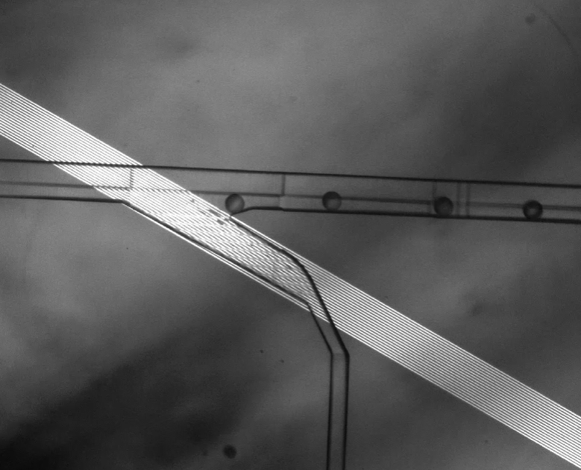

Figure 1: IDE (white) powered on below threshold voltage and droplets remain unfiltered

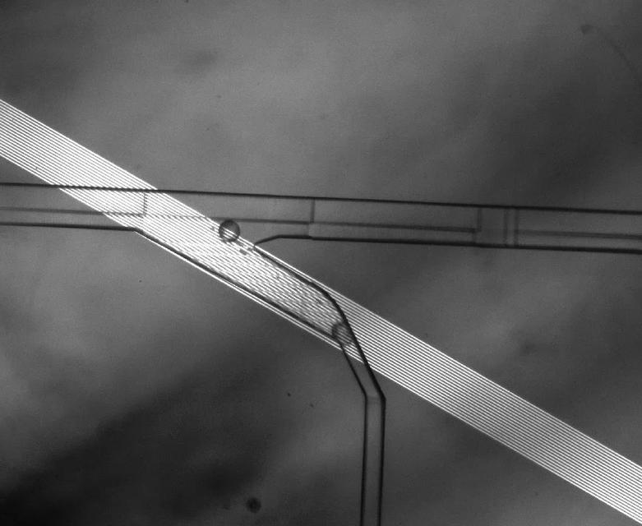

Figure 2: IDE powered on at/above threshold voltage and droplets are filtered.

**3. IDE Parameter Experiment**

## ***3.1. Overview***

The purpose of this set of experiments is to investigate the relationship between IDE design and droplet filtration accuracy. The IDE designs vary by finger width and spacing. Three designs are tested, where finger width and spacing are each equal to 5 µm, 10 µm, and 20 µm. A plethora of droplets varying in size, known as polydisperse droplets, are generated by mixing a solution of Novec synthetic oil and distilled water in a test tube and shaking it rigorously. These droplets are then reflowed into an inlet and allowed to flow through the microchannel. An AC voltage is applied to all three IDEs via function generator. Below, Figures 16, 17, and 18 show results from this set of experiments, comparing droplet collections at each outlet. The categories on the x axis, including true positive, false positive, true negative, and false negative, are defined in Figure 3.

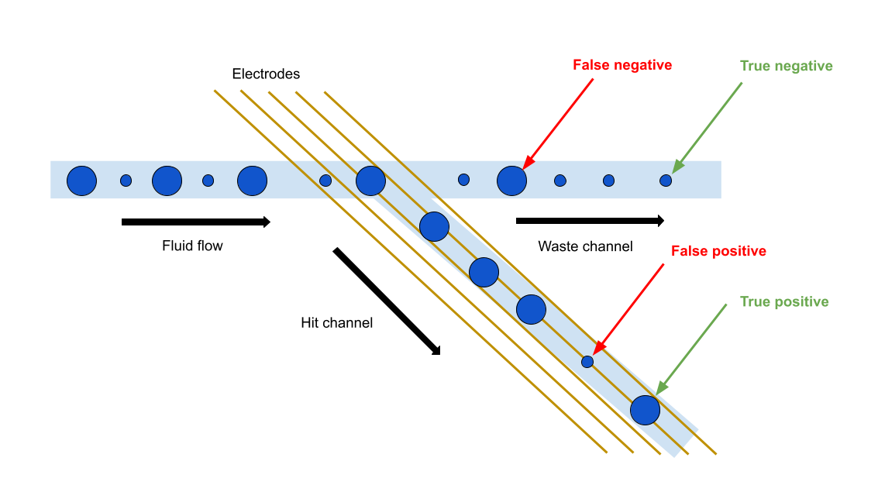

*Figure 3: Definitions of true positive, false positive, true negative, and false negative.*

## ***3.1. Results***

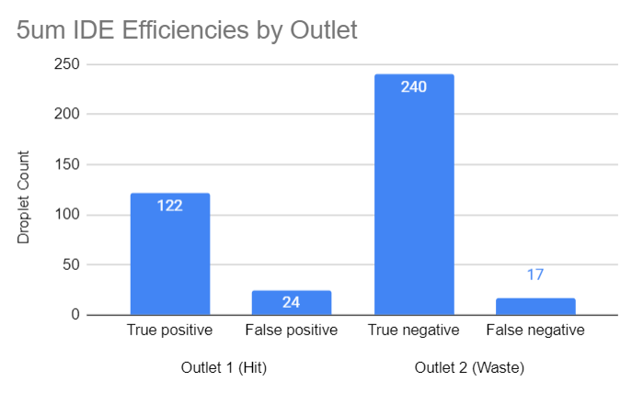

Figure 4: Results of the 5 µm IDE experiment.

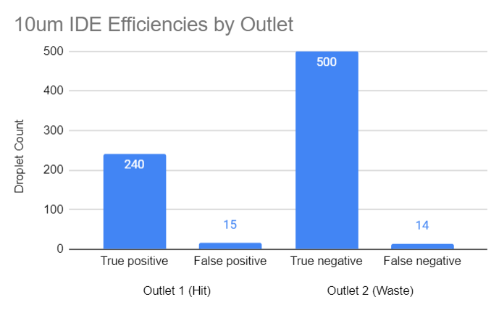

Figure 5: Results of the 10 µm IDE experiment.

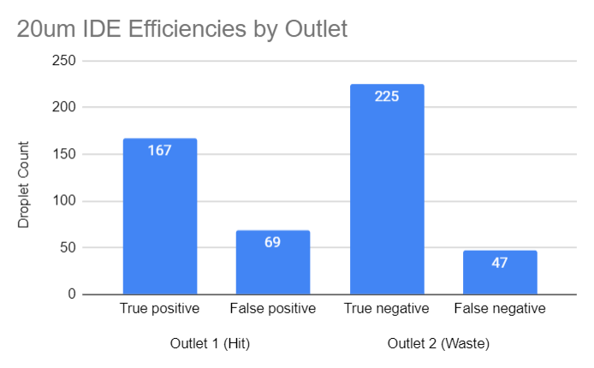

Figure 6: Results of the 20 µm IDE experiment.

The efficiencies for these results can be calculated in a few different ways. Looking at the performance of the filter overall, we can use Equation 1 to evaluate efficiency. To look at the performance of individual outlets, we can use Equations 2a and 2b:

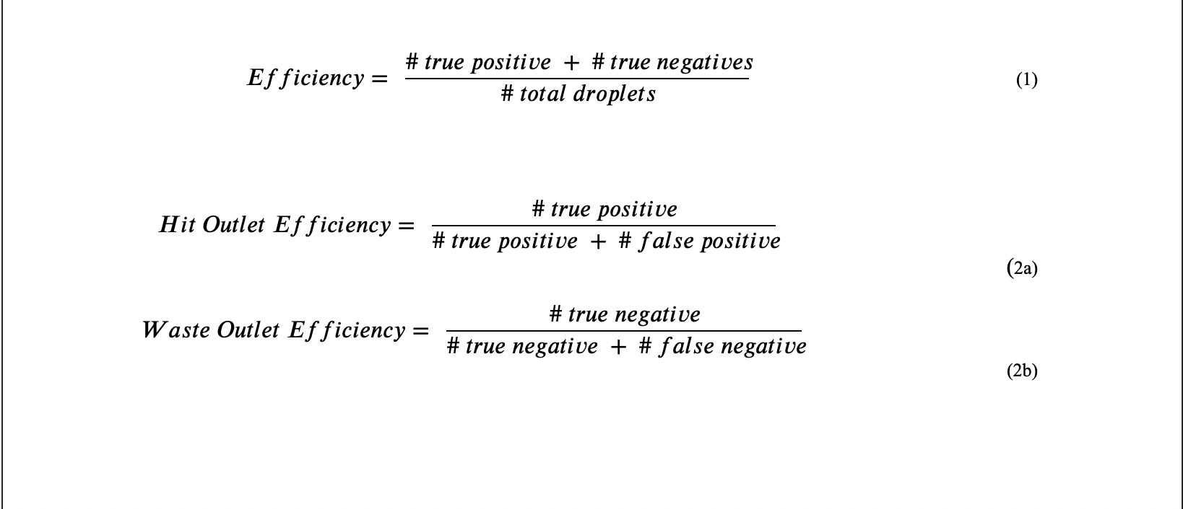

This yields overall efficiencies of 89.56% for the 5 µm IDE, 96.23% for the 10 µm, and 77.17% for the 20 µm IDE. These results make sense within the context of our simulations. The simulations gave insight on the height and strength of the electric fields produced by each IDE design. The 5 µm IDE produced very strong electric fields, but they did not reach as high as the 20 µm IDE. Conversely, the 20 µm produced much weaker electric fields, but reached greater heights than the 5 µm IDE. These two extremes yielded trade offs consisting of field strength and range. With the 10 µm IDE right in the middle, this design is in the “goldilocks” zone, making a compromise between field strength and height.

Further analyzing the devices, the 5 µm IDE hit outlet yielded a filtration efficiency of 83.56% while the waste outlet yielded a 93.39% efficiency. The 10 µm IDE hit outlet had an efficiency of 94.12% and a waste outlet efficiency of 97.28%. Finally, the 20 µm IDE hit outlet proved to have a hit outlet efficiency of only 70.76%, and waste outlet efficiency of 82.72%. By this analysis, the 10 µm again emerges as the victor. These findings apply to both the high pass filter device and the band pass filter device.

# **4. Conclusion**

## ***4.1. Purpose***

The purpose of our research is to apply interdigitated electrodes to droplet microfluidic systems to filter out and sort droplets based on size. To do this two sets of experiments were conducted. The first was to determine the effect droplet size has on the threshold voltage needed to sort droplets. The second set of experiments was conducted to determine the impact different IDE parameters play on droplet sorting accuracy.

## ***4.2. Results Overview***

The Droplet Size vs Threshold Voltage experiment set gave insights on what applied voltage to the IDEs is needed to achieve droplet filtration on certain droplet sizes. These results can be seen in Table 1. As expected, a greater applied voltage is needed to effectively filter droplets of larger diameters. Because of the droplets’ natural buoyancy combined with the lifting oil bias introduced to the microchannels, droplets tend to float to the top surface of the microchannels while the IDEs exist at the bottom surface of the channels. Thus, large droplets reach further towards the bottom surface of the channel than small droplets do. Greater applied voltage leads to stronger electric fields that reach higher in the channel, producing a greater DEP force; therefore, it makes sense that greater voltages are needed to affect large droplets due to their greater inertia and momentum as compared to small droplets.

The IDE Design vs Droplet Filtration set of experiments gave insights on what IDE array designs maximize droplet filtration accuracies. IDE array designs differ by width and spacing of the electrode fingers. Three different designs were tested in these experiments: 5 µm, 10 µm, and 20 µm finger width and spacing, where width and spacing are always equal. Prior to experiments, simulations were completed to give us insights on what electric fields would be produced by each design. It was discovered that the 5 µm design yielded the strongest electric field while the 20 µm design yielded the weakest; however, the 20 µm electric field had greater reach than the 5 µm. The 10 µm design sat in the middle for both electric field strength and reach, foreshadowing that it would be a compromise between the strength of the 5 µm design and the range of the 20 µm design. Post-experiment and analysis, this was confirmed. The 10 µm IDE array gave rise to a 96% filtration accuracy. The 5 µm IDE array was the second runner up at nearly 90%, and in last place was the 20 µm array at a mere 77%.

## ***4.3. Applications***

Size-based filtration technology has the potential to solve many problems that arise from non-uniform droplet sizes in droplet microfluidic systems and experiments. The high-pass filter system outlined in this paper has great potential to efficiently remove unwanted satellite droplets from a system quickly after they form. Additionally, the band-pass filter can efficiently remove split and merged droplets which commonly occur in PCR applications, due to the thermal cycles used during nucleic acid amplification.

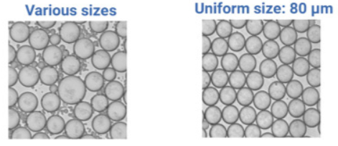

*Figure 7: (Left) Droplet collection pool post-PCR, with many split and merged droplets. (Right) Droplet collection pool post-IDE filtration, with all droplets at a uniform size of 80 µm.*

Further and more specific applications of the size-based droplet filtration technology developed in this paper include cell biology, drug screening, and nucleic acid analysis.

In a cell biology scenario, we look specifically at the case of library generation for viral phages that are effective against antibiotic resistant bacterial infections, where droplets can merge with desired droplets or split from droplets containing sensitive organic compounds where mixing is not tolerated. The result is a set of false positive or false negative results which might require retesting and can be expensive as well as time consuming.

Droplet microfluidics has great potential in drug discovery since microfluidic systems consume only a few microliters of sample and requires small cell number numbers for performing large-scale studies. Encapsulation of single cells is essential in such experiments. Co-encapsulation of different cell types due to merging of droplets can be problematic. Using size-based filtration, over-merged droplets can be efficiently sorted out of the sample pool.

Finally, the application of single-cell genome sequencing has been hindered by challenges in isolating single cells during genome preparation. Microfluidics techniques including trapping the cells of interest in hydrogel microspheres are used and optimization of ultra-high throughput microfluidics with size-based filtration can further contribute to compartmentalization of each genome.

## ***4.4. Future Work***

To continue this work, experiments using satellite droplets and real droplets processed via PCR should be performed. Additionally, the technique of size-based filtration may be further enhanced by researching the effects of PECVD coating thickness on voltage applied to the IDE, as well as the thickness of the gold IDE fingers on filtration.